# 473 CSM Software Engineering II

# Activity 1 - 2 Marks

* Configure your git user name and email. Take a screenshot of the commands you used.

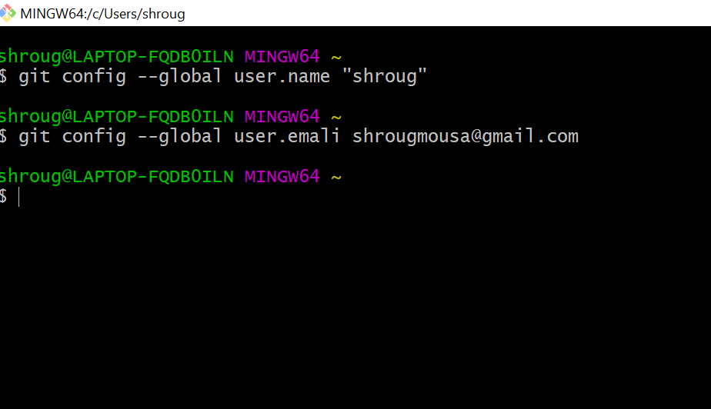

* Create a new repository inside a folder of your choice.
* 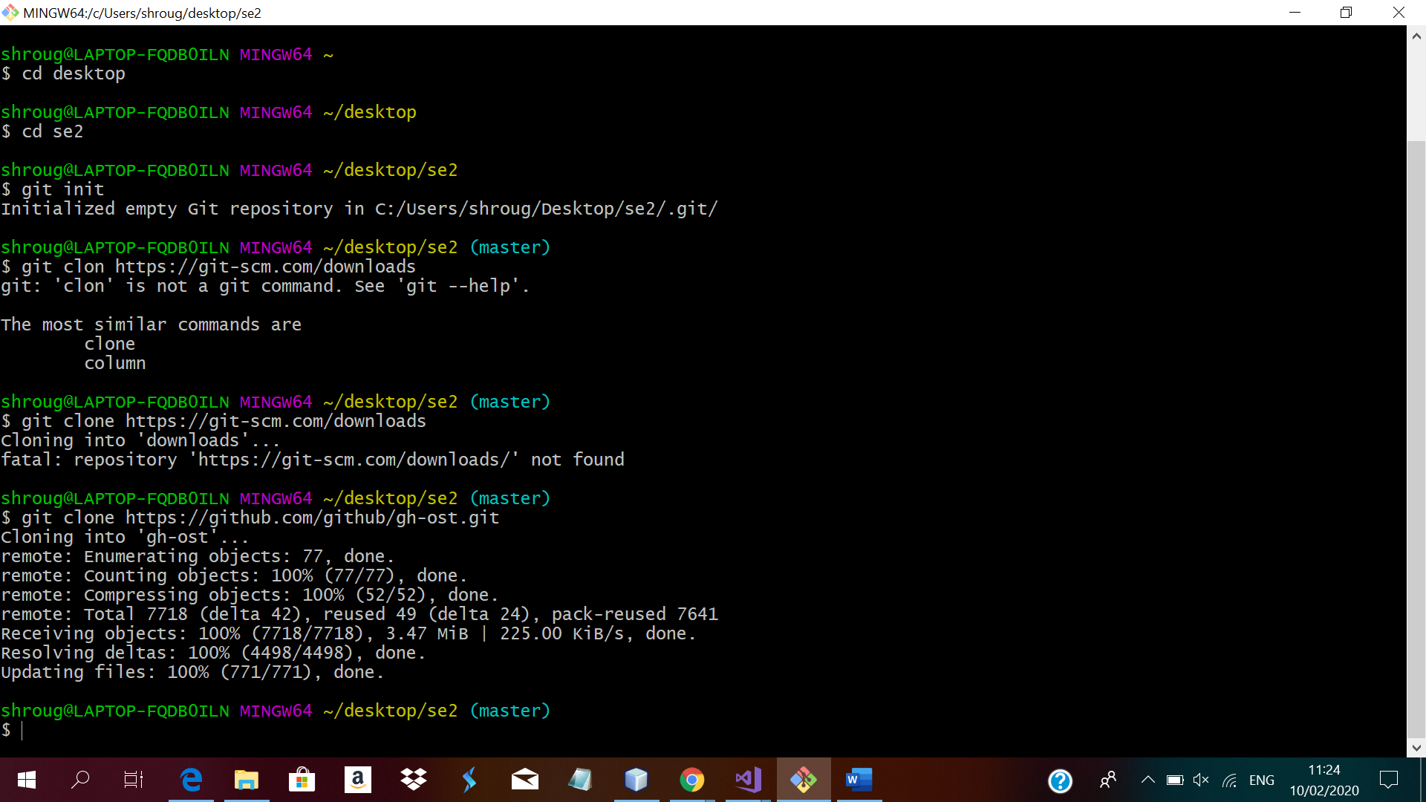
* Clone a repository from a remote repository.

